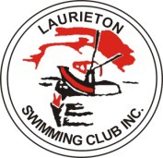

Laurieton Swimming Club Inc

STROKE POINT SCORE 2025-26

Freestyle
A Grade Michael Tinker
B Grade Laylee Spinazza
C Grade Rose Garner
D Grade Emily Gale

Backstroke:
A Grade Harry Santman
B Grade Jenna Pepperell / Poppy Ross
C Grade Alice Hayward
D Grade Ashton Ross

Breaststroke:
A Grade Harry Santman
B Grade Rali Pensini
C Grade Tommy Cass
D Grade Ashton Ross

Butterfly:
A Grade Harry Santman
B Grade Emily Wheadon
C Grade Alice Hayward
D Grade Isabella Fede

