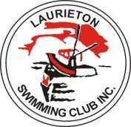

Laurieton Swimming Club Inc

STROKE POINT SCORE 2024-25

Freestyle
A Grade Maya Hardy
B Grade Alyssa Donohue / Ara Fuller
C Grade Laura Eccleston
D Grade Emily Gale / Jasper Maxwell

Backstroke:
A Grade Georgie Cas
B Grade Maya Hardy
C Grade Tayler Cass
D Grade Julie Eccleston

Breaststroke:
A Grade Ben Santman
B Grade Harry Santman
C Grade Tayler Cass
D Grade Jasper Maxwell

Butterfly:
A Grade Thomas Maxwell
B Grade Jenna Pepperell
C Grade Ara Fuller
D Grade Karen Eccleston

